
BULE HORA UNIVERSITY
COLLEGE OF COMPUTING AND INFORMATICS
DEPARTMENT OF SOFTWARE ENGINEERING
COURSE TITLE: SOFTWARE ENGINEERING TOOLS AND PARACTICE
COURSE CODE: Seng 5331
GROUP ASSIGNMENT

Group members ID
- Abreham Leta……………………………….RU 0147/16
- Woyneshet Meyu …………………………RU 0141/16
- Tamiru Chalchisa ………………………….RU 0177/16
- Nigussie Dejen ………………………………RU 0276/16

Submitted to: Mr. Getahun F
Submission date:30/03/2018 EC
BULE HORA, ETHIOPIA

Abstract
The Online Voting System is a digital platform designed to modernize and streamline election processes by replacing traditional manual voting methods with a secure, automated, and user-friendly electronic system. The system enables voters to register, authenticate, and cast their votes online, while administrators efficiently manage voter data, candidates, election schedules, and real-time results. By automating vote counting and verification, the platform eliminates common issues found in manual voting—such as human error, delays, logistical challenges, and lack of transparency. The system ensures data integrity, prevents duplicate voting, and provides instant result generation, thereby improving both efficiency and credibility. This report examines the system’s domain analysis, functional and non-functional requirements, process workflows, system constraints, and technical concepts, including Git and GitHub as essential development tools. Overall, the Online Voting System contributes to secure, efficient, and transparent election management suitable for academic institutions and similar organizations.

Table content
Catalog
Abstract 2
TITLE: ONLINE VOTING SYSTEM 4
1. Introduction 4
2. Problem Statement 4
3. Stakeholder Analysis 5
Primary Stakeholders 5
1. Voters 5
3. Candidates 6
Secondary stakeholdres 6
4. Domain Objectives 6
5. Functional Domain Requirements 6
5.1 User Registration and Authentication 6
5.2 Voter Operations 7
5.3 Admin Operations 7
5.4 Vote Casting and Recording 7
5.5 Real-Time Results Display 7
6. Non-Functional Domain Requirements 8
6.1 Security 8
6.2 Performance 8
6.3 Reliability 8
6.4 Scalability 8
6.5 Usability 8
6.6 Availability 8
7. Domain Constraints 8
8. Domain Entities and Concepts 9
Voter 9
Admin 9
Candidate 9
Election 9
Vote 9
Results 9
Admin 9
Candidate 9
Election 9
Vote 9
Results 9
9. Domain Processes (High-Level) 9
Registration Process 9
Login Process 9
Voting Process 9
Result Calculation Process 10
10. Domain Scope 10
Included 10
Excluded 10
CLASS DIAGRAM IMAGE OF ONLINE VOTING SYSTEM 11
SEQUENSE DIAGRAM IMAGE OF ONLINE VOTING SYSTEM 12
Some Concept About Github 13
1. Version Control 13
2. Distributed System 13
3. Branching and Merging 14
4. Collaboration 14
5. Commits and History 14
6. Repository (Repo) 14
7. Staging Area (Index) 15
8. Advantages of Git 15
Difference Between Git and GitHub 15
1. Definition 15
2. Type of Tool 15
3. Function 15
4. Usage 16
5. Internet Requirement 16
6. Collaboration 16
7. Features 16
Git: 16
GitHub: 16
8. Ownership 17
9. Repository Types 17
In Simple Words 17
Configuration of Git and GitHub 18
1. Git Installation 18
2. Initial Git Configuration 18
3.GitHub Account Configuration 19
4. Local Repository Configuration 19
5 . Adding and Committing Files 20
6 . Connecting Git to GitHub 20
7. Authentication Configuration 20
8.Pushing Code to GitHub 21
SUMMARY 22
Reference 23

TITLE: ONLINE VOTING SYSTEM

1. Introduction
The Online Voting and Result Management System operates within the domain of electronic election management, which focuses on facilitating secure, efficient, and transparent voting processes. Traditional paper-based voting systems face challenges such as delays in result counting, human error, limited accessibility, and logistical costs. The online voting domain aims to automate these processes by providing a digital platform where voters authenticate themselves, cast their votes securely, and administrators manage elections efficiently.
This domain emphasizes authentication, authorization, data integrity, confidentiality, and real-time result computation. It replaces manual procedures with automated processes while ensuring fairness, accuracy, and audit ability.

2. Problem Statement
The domain addresses key problems associated with traditional voting:
· Time-consuming registration and result processing
· High vulnerability to human error
· Difficulty in managing large voter populations
· Lack of transparency and real-time updates
· Resource consumption (paper, manpower, logistics)
The system aims to provide a secure, reliable, fast, and transparent digital alternative.

Stakeholder Analysis

Primary Stakeholders
- Voters
· Must register, log in, and vote once.
· Require a simple, user-friendly interface.

- Administrators (Election Officers)
· Manage users, candidates, election schedules, and results.
· Need a secured dashboard.
- Candidates
· Participate in elections and receive votes.
· Their vote count is displayed in results.

Secondary stakeholdres
· System Developers
· University Management / Government Agency
· Auditors (optional, for verifying results)

Domain Objectives
The central objectives include:
· Provide a trusted platform for casting votes online.
· Prevent multiple voting using authentication and voter status tracking.
· Ensure accurate and automatic vote counting.
· Generate real-time, error-free results.
· Allow admins to manage elections conveniently.
· Improve accessibility for remote voters.

Functional Domain Requirements

5.1 User Registration and Authentication
· Voters create accounts with unique identifiers.
· Admins approve or manage voter accounts.
· System validates credentials and controls system access.

5.2 Voter Operations
· Log in to the system
· View election details
· View list of candidates
· Cast exactly one vote
· Receive confirmation after voting
· Cannot vote again after submission

5.3 Admin Operations
· Manage voter list (add, update, delete)
· Add and manage candidates
· Create and manage election schedules (start & end dates)
· Monitor voting progress
· View result summaries or detailed reports
· Publish final results

5.4 Vote Casting and Recording
· System verifies if voter has not voted
· Vote is recorded against candidate
· Vote timestamp is stored
· has-voted field updated

5.5 Real-Time Results Display
· Total votes per candidate
· Percentage of votes
· Graphical results (optional)
· Result generation after election ends

Non-Functional Domain Requirements

6.1 Security
· Password hashing
· Role-based access control
· Protection against duplicate voting
· Secure data storage

6.2 Performance
· Fast authentication
· Quick loading of candidate profiles
· Real-time result computation

6.3 Reliability
· System must operate accurately without losing votes
· No downtime during election hours

6.4 Scalability
· Able to handle large numbers of voters concurrently

6.5 Usability
· Simple interface
· Clear navigation for voters and admins

6.6 Availability
· Accessible during the entire election period

Domain Constraints
· Voter must only vote once
· Admins have full privileges, but voters have limited privileges
· Election can be cast only during active time window
· Results cannot be modified manually

Domain Entities and Concepts

Voter
Individual allowed to cast a vote; identified uniquely and restricted to one vote.

Admin
Manages entire system; has full authority.

Candidate
A person running in the election for a specific position or role.

Election
Defines scope, timing, candidates, and eligibility.

Vote
A record storing voter’s choice. Represents the core action of the system.

Results
Computed outcome from collected votes, often in table or chart form.
Individual allowed to cast a vote; identified uniquely and restricted to one vote.

Admin
Manages entire system; has full authority.

Candidate
A person running in the election for a specific position or role.

Election
Defines scope, timing, candidates, and eligibility.

Vote
A record storing voter’s choice. Represents the core action of the system.

Results
Computed outcome from collected votes, often in table or chart form.

Domain Processes (High-Level)

Registration Process
Voter submits info
System validates
Admin approves (optional)

Login Process
User enters credentials
System authenticates
Access granted based on role (admin or voter)

Voting Process
Voter checks candidate list
Voter selects one candidate
System records vote
Updates hasVoted flag
Confirmation displayed

Result Calculation Process
System counts votes per candidate
Generates statistics and percentages
Display results to admin or public

Domain Scope

Included
Account management
Secure login
Voting dashboard
Admin panel
Candidate management
Vote counting
Result publication

Excluded
Biometric authentication
Mobile app platform (unless specified)
Multi-level elections (unless specified)
Offline voting

CLASS DIAGRAM IMAGE OF ONLINE VOTING SYSTEM

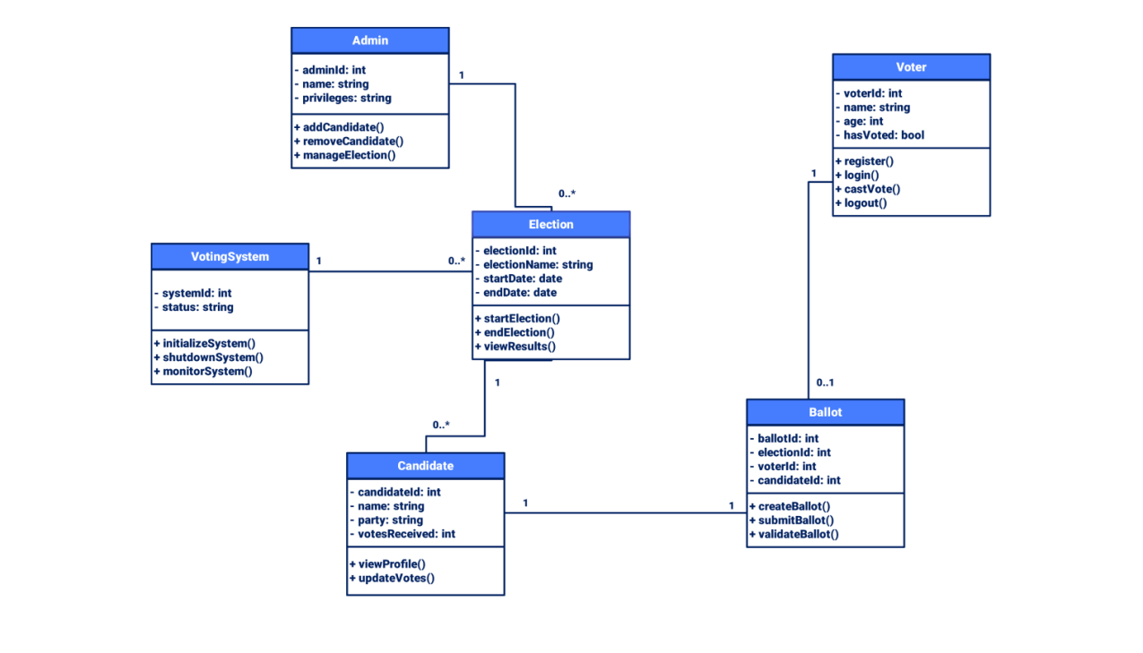

SEQUENSE DIAGRAM IMAGE OF ONLINE VOTING SYSTEM

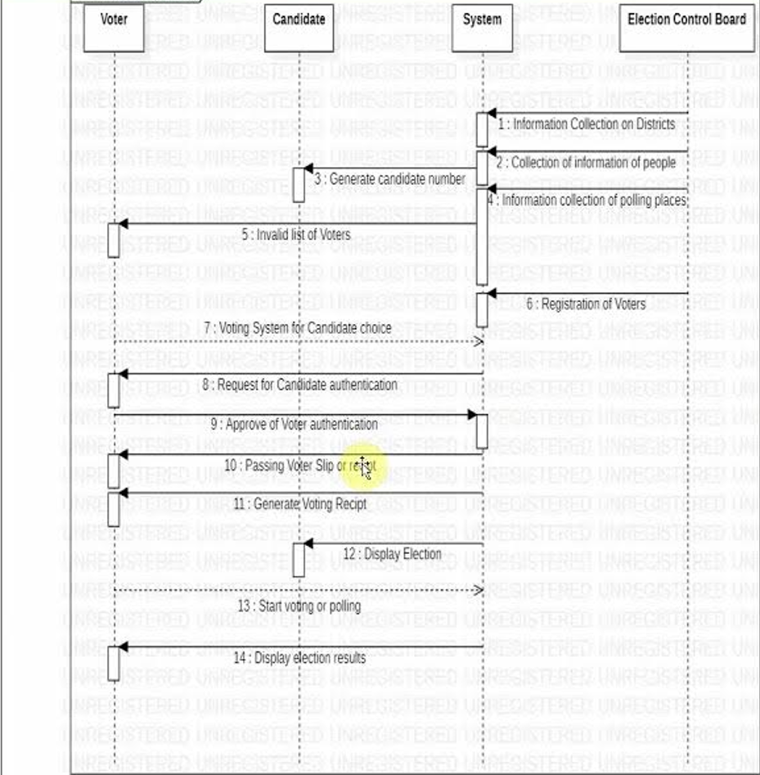

Some Concept About Github
GitHub is a powerful cloud-based platform that builds on the Git version-control system to help developers track changes, collaborate, and manage software projects more efficiently. It provides centralized repositories where code can be stored, updated, and shared with individuals or large development teams. Using GitHub, developers can create branches to test new ideas without disrupting the main project, submit pull requests to propose changes, and review code collaboratively to ensure quality and consistency. Beyond version control, GitHub offers many additional features such as project boards, issue tracking, wikis, documentation hosting, and automated workflows through GitHub Actions, which support continuous integration and deployment (CI/CD). The platform also supports open-source development, allowing millions of developers worldwide to contribute to public projects by forking repositories and submitting improvements. With strong security tools, community engagement features, and integration with countless development environments, GitHub has become an essential platform for modern software development, project management, and collaborative learning.

Git is a distributed version control system (DVCS) used to track changes in files and manage collaborative software development. Created by Linus Torvalds in 2005, Git has become the most widely used version control tool because of its speed, flexibility, and efficiency in handling large projects.

1. Version Control
Git allows developers to keep a complete history of changes made to a project. Each change is saved as a commit, which records what was modified, when, and by whom. This makes it easy to:
Revert to earlier versions
Compare changes
Recover deleted or overwritten files
Version control ensures that no work is permanently lost.

2. Distributed System
Unlike centralized systems, Git stores the entire project history on every developer’s computer. This provides major advantages:
You can work offline
Git operations are faster
No single point of failure
Every developer has a backup of the full repository
This distributed nature makes Git safe and highly reliable.

3. Branching and Merging
One of Git’s strongest features is its branching model. Developers can create branches to experiment, add features, or fix bugs without affecting the main project.
Branches allow parallel development
Merging brings changes together
Teams can work independently without conflict
This promotes better workflow and cleaner project organization.

4. Collaboration
Git simplifies teamwork by letting multiple contributors work on the same codebase simultaneously. It prevents conflicts and overwriting of code by:
Tracking each developer’s commits
Allowing code review before changes are added
Managing conflicts automatically when possible
Git makes it easy for large teams to coordinate their work.

5. Commits and History
A commit is a snapshot of the project at a particular moment. Git stores:
Who made the change
What changed
Why (usually via commit messages)
The commit history acts as a timeline of development, helping teams understand the evolution of the project.

6. Repository (Repo)
A repository is the place where Git stores all project files and their entire history. There are two types:
Local repository: Stored on your computer
Remote repository: Stored on a server (e.g., GitHub, GitLab)
Repos allow developers to sync work, share updates, and collaborate easily.

7. Staging Area (Index)
Git uses a staging area where files are prepared before they are committed. This gives developers full control over which changes should be saved, allowing more accurate commit histories.

8. Advantages of Git
Git provides many benefits such as:
Fast performance
Strong branching and merging capabilities
Full history tracking
Easy collaboration
Secure backup through distributed repositories
Efficient handling of small and large projects

Difference Between Git and GitHub

1. Definition
Git is a distributed version control system used to track changes in files and manage project history.
GitHub is an online hosting platform that stores Git repositories and supports collaboration.

2. Type of Tool
Git: A software/tool installed on your computer.
GitHub: A web-based service/platform accessed online.

3. Function
Git: Manages versions, commits, branches, and merges locally.
GitHub: Provides a remote place to store Git repositories, share them, and collaborate with others.

4. Usage
Git: Used through command line or GUI apps to manage code history.
GitHub: Used through a web browser for hosting code, reviewing changes, and team coordination.

5. Internet Requirement
Git: Works offline; no internet needed for version control.
GitHub: Requires an internet connection to access and use repositories.

6. Collaboration
Git: Supports collaboration locally, but developers need a shared server to sync changes.
GitHub: Makes collaboration easy by providing pull requests, issues, code review, and team discussions.

7. Features

Git:
Commits
Branching and merging
Local repository management

GitHub:
Remote repositories
Pull requests
Issues and bug tracking
Wiki and documentation
GitHub Actions (automation/CI-CD)
Project boards

8. Ownership
Git: Open-source tool created by Linus Torvalds.
GitHub: A Microsoft-owned platform.

9. Repository Types
Git: Only local and self-hosted repos.
GitHub: Offers public and private repositories stored on GitHub's servers.

In Simple Words
Git = Version control software for tracking changes
GitHub = Cloud platform for hosting and collaborating on Git projects

Configuration of Git and GitHub

Git Installation

1.1 Verify Git Installation
Open Command Prompt or Terminal and run:
git --version

If Git is installed, a version number will appear.

1.2 Install Git (If Not Installed)
1. Visit git-cm.com
2. Download Git for your operating system
3. Install using default settings

2. Initial Git Configuration
Git requires user information before tracking changes.

2.1 Configure Username
git config --global user.name "username"
This name appears in every commit.

2.2 Configure Email Address
git config --global user.email "your_email@example.com"
Use the same email as your GitHub account.

2.3 Verify Configuration
git config --list

2.4 Configure Default Branch Name
git config --global init.defaultBranch main

2.5 Configure Text Editor (Optional)
Example for VS Code:
git config --global core.editor "code --wait"

3.GitHub Account Configuration

3.1 Create a GitHub Account
1.Visit github.com
2.Sign up
3.Verify email
4.Log in

3.2 Create a New Repository
1.Click New Repository
2.Enter repository name
3.Select Public or Private
4.Click Create Repository

4. Local Repository Configuration

4.1 Initialize Git Repository
Navigate to your project folder:
cd project-folder
git init

4.2 Check Repository Status
git status

5 . Adding and Committing Files

5.1 Add Files to Staging Area
git add .

5.2 Commit Files
git commit -m "Initial commit"

6 . Connecting Git to GitHub

6.1 Add Remote Repository
git remote add origin https://github.com/USERNAME/REPOSITORY.git

6.2 Verify Remote
git remote -v

Authentication Configuration
GitHub requires secure authentication.
Option A: Personal Access Token (PAT)
Steps:
1.GitHub → Settings
2.Developer Settings
3.Personal Access Tokens
4.Generate New Token
5.Select scopes: repo
6.Save the token securely
Use this token as your password when Git prompts.
Option B: SSH Key Configuration (Recommended)

Generate SSH Key
ssh-keygen -t ed25519 -C "your_email@example.com"
Press Enter to accept default settings.

7.2 Start SSH Agent
eval "$(ssh-agent -s)"
ssh-add ~/.ssh/id_ed25519

7.3 Add SSH Key to GitHub
- Copy public key:
cat ~/.ssh/id_ed25519.pub
- GitHub → Settings → SSH and GPG keys
- Click New SSH key
- Paste key and save

7.4 Test SSH Connection
ssh -T git@github.com

8.Pushing Code to GitHub
git branch -M main
git push -u origin main

8.1 Daily Git Workflow
- Edit files
- Check status
git status
- Add changes
git add .
- Commit changes
git commit -m "Meaningful message"
- Push to GitHub
git push

SUMMARY
The Online Voting and Result Management System is a modern digital solution designed to replace traditional, paper-based voting methods with a secure, efficient, and automated electronic platform. The system provides functionalities for voter registration, authentication, vote casting, and real-time result generation. It aims to eliminate human-error, reduce delays, minimize resource usage, and enhance the transparency and credibility of the voting process.
The domain focuses on ensuring secure access, preventing duplicate voting, maintaining voter privacy, and guaranteeing the accuracy of results. Administrators can manage voters, candidates, and the entire election cycle through a controlled interface, while voters are provided with an intuitive platform for participating in the election.
By automating vote counting and result processing, the system ensures real-time availability of election outcomes, supports scalability for large voter populations, and offers improved reliability and accessibility. Overall, the domain contributes to advancing democratic practices within institutions by leveraging technology to make elections faster, more transparent, and more user-friendly.
Git is a distributed version control system that allows developers to track changes in their code, manage project histories, create branches, and work offline. It operates locally on a computer and focuses mainly on version control and file management. GitHub, on the other hand, is an online platform built on top of Git that provides a cloud-based environment for hosting Git repositories, enabling collaboration, sharing, and team workflow management. While Git manages how code changes are recorded, GitHub provides additional tools such as pull requests, issue tracking, documentation support, automation, and project management features. In simple terms, Git handles how developers track changes, while GitHub handles how they share and collaborate on those changes through a web platform.

Reference
· Chacon, S., & Straub, B. (2014). Pro Git (2nd ed.). Apress.
(Official Git book, available free at: https://git-scm.com/book)
· Git. (n.d.). Git Documentation. Git-SCM.
Retrieved from https://git-scm.com/doc
· GitHub. (n.d.). GitHub Documentation. GitHub, Inc.
Retrieved from https://docs.github.com/

